Elad Hayek - 211873542
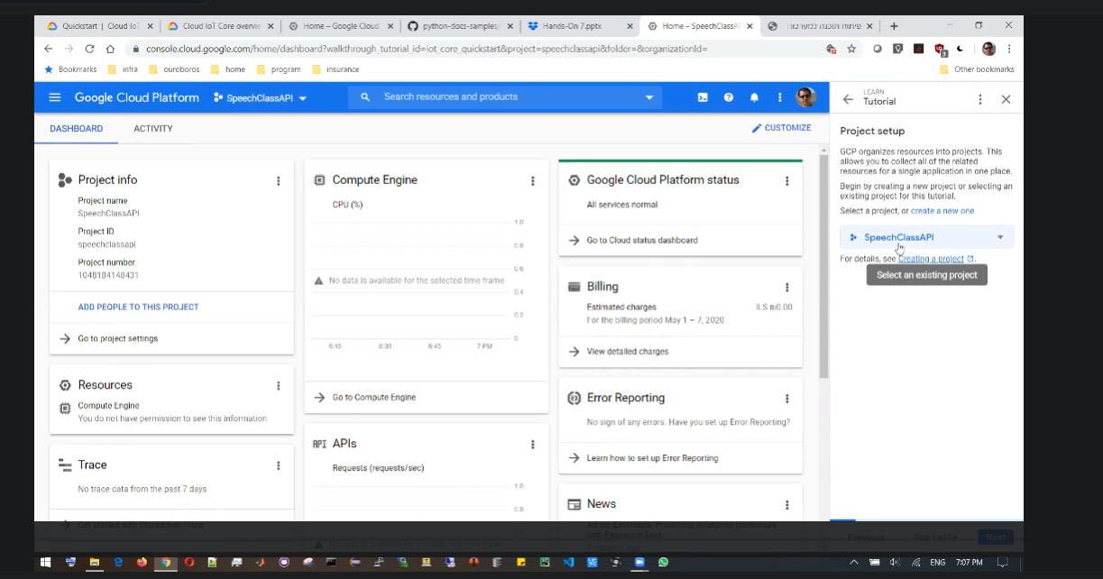
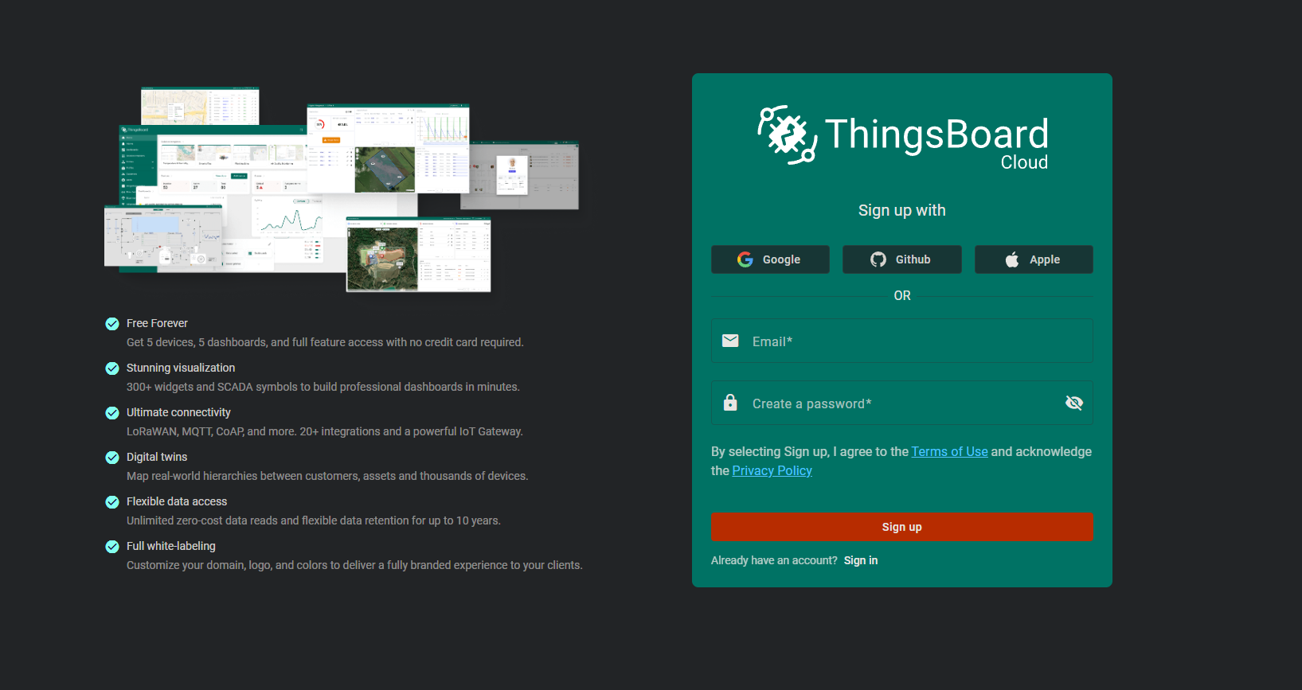
The site in the instruction video is not the same as the site in the TODO link in the assignment.

